**RASA WORK**

**ABDUL SABOOR**

1. **DATA PREPROCESSING:**

* Remove junk data
* Remove duplicates
* Remove meaningless sentence from the data
* Shuffling the data
* Split data into train and test
* Conversion of train data into json format

1. **Training on Rasa Model**

After training we test data and get the accuracy

To improve the accuracy we try on different models and also cleaned the data in different ways

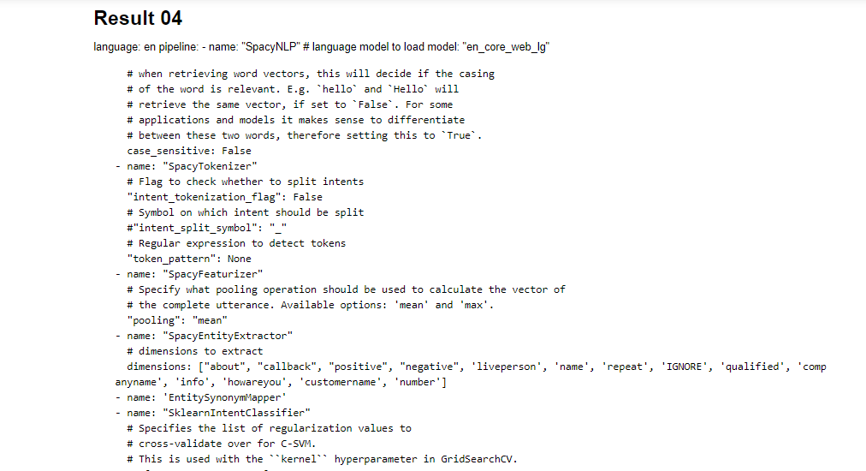 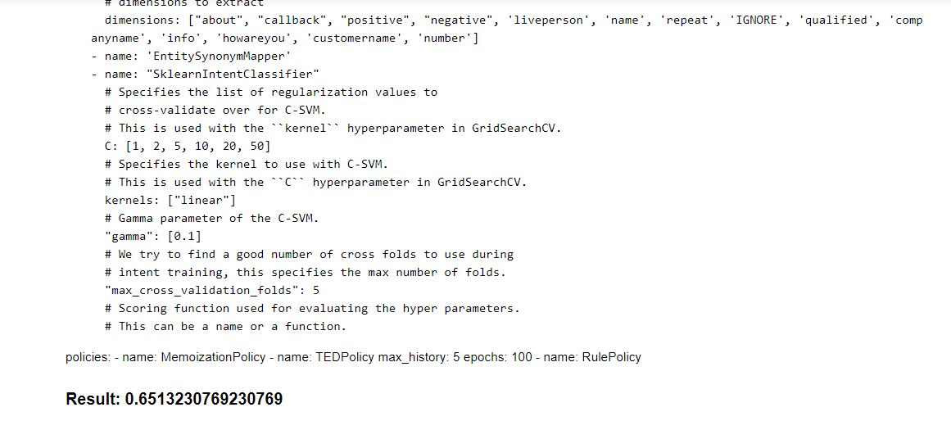 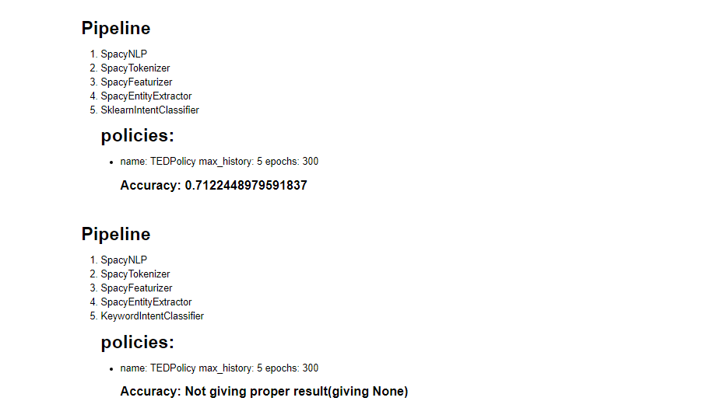

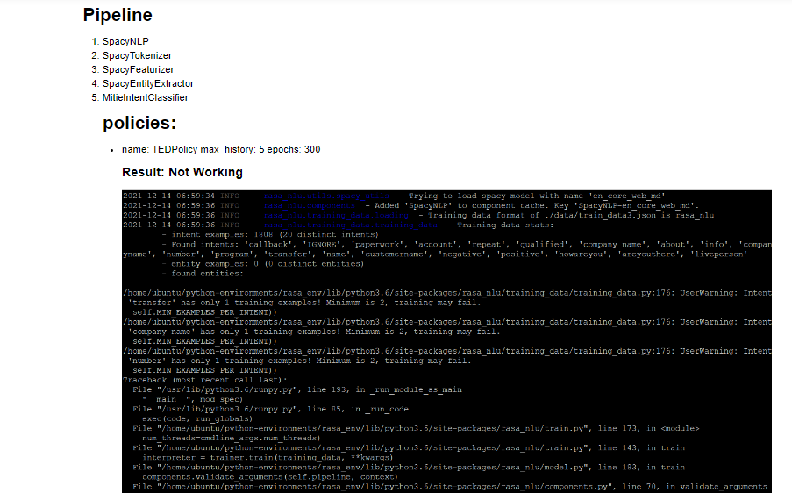

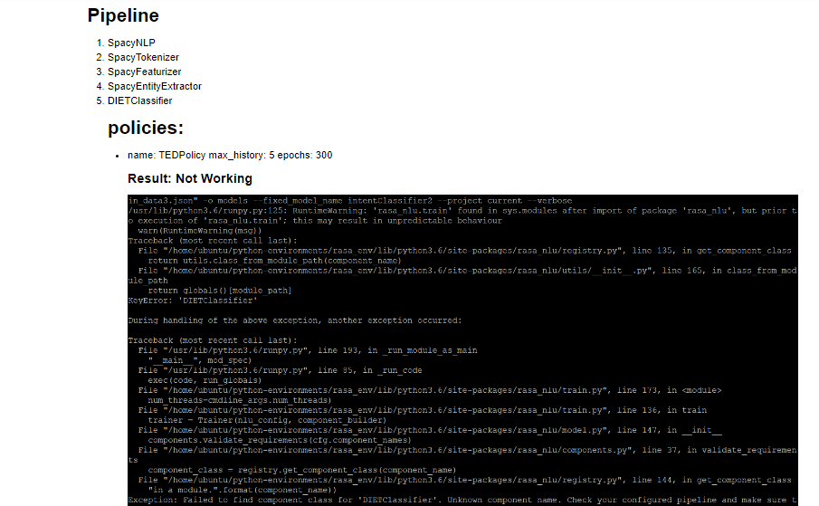

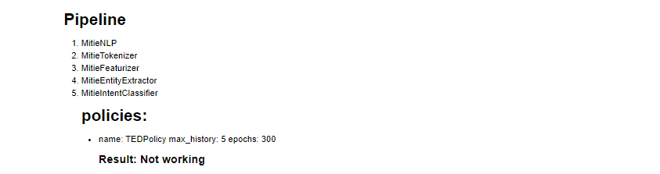

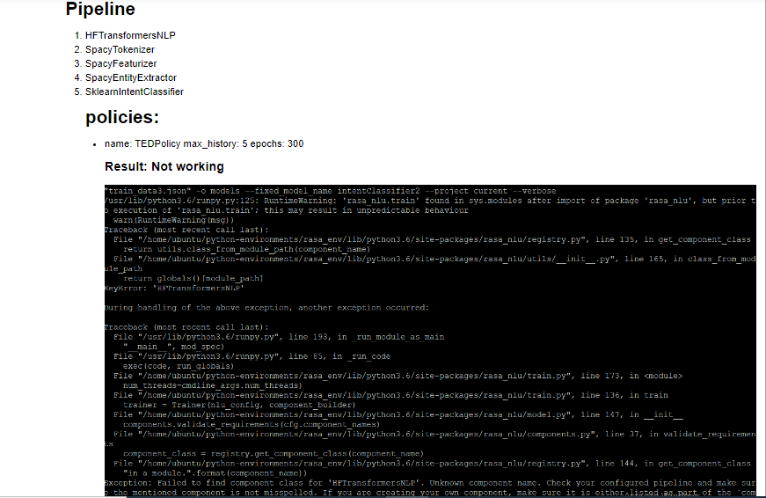

1. **We download different data from kaggle then combine into one json file and train our model on this data**

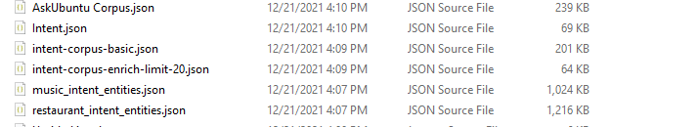

**We get this accuracy on kaggle data**

* Tensorflow model

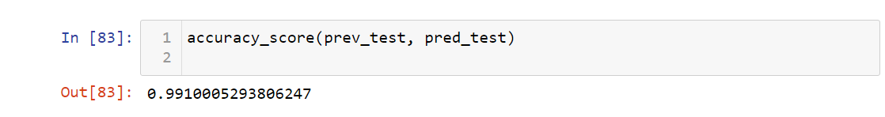

* **Kaggle data Inents**

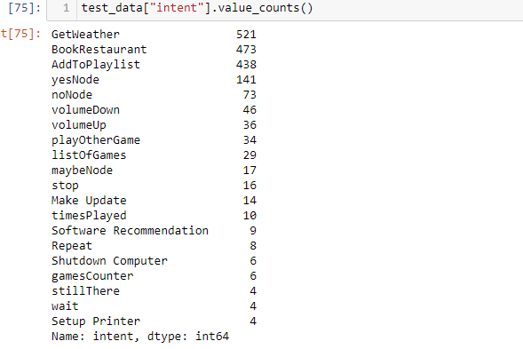

* **Manual Testing**

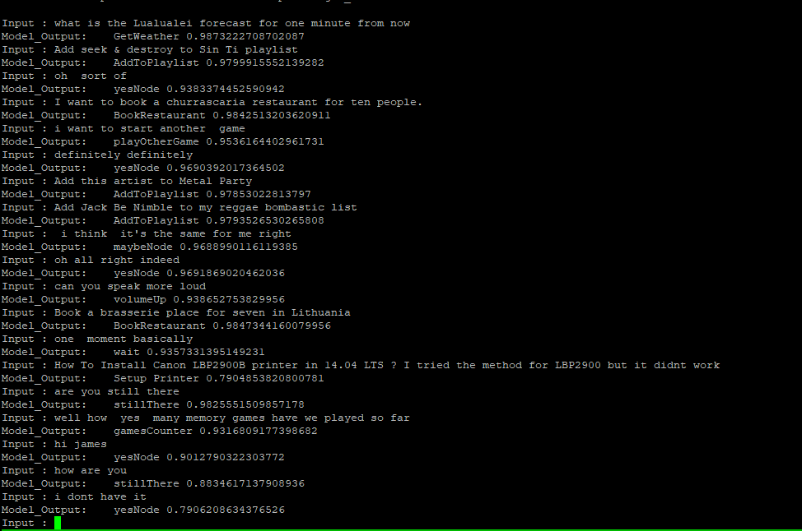

* **Spacy Model**

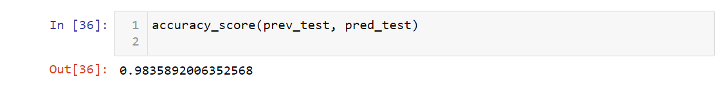

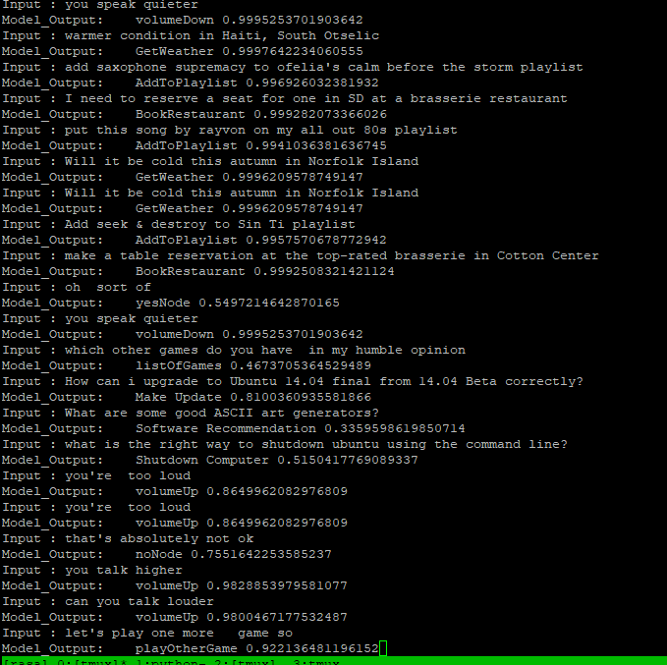

* **Our data after removing short sentences**
  + **Intent classifier3 model accuarcy**

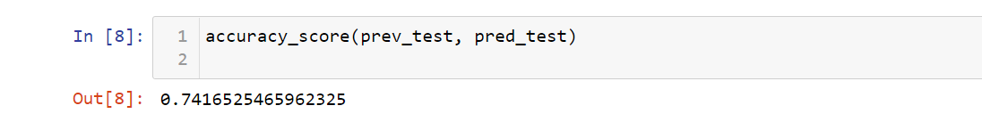

* 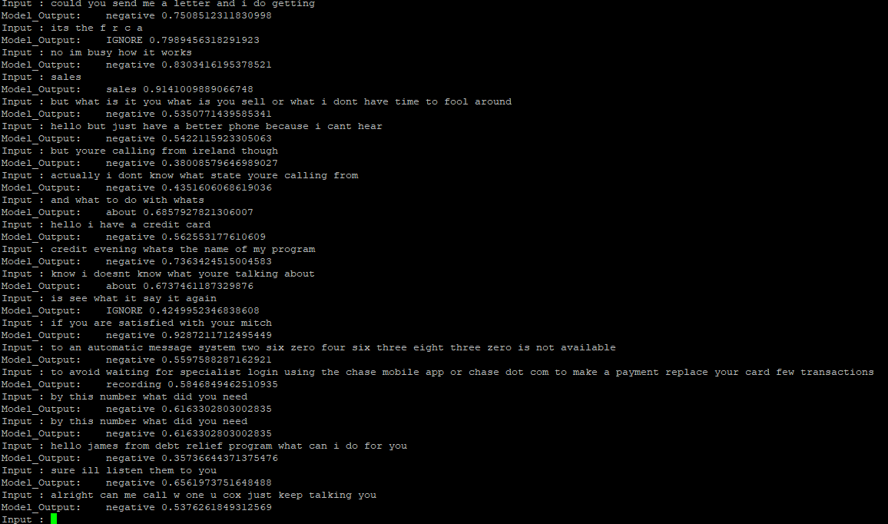
* In manual testing our model is biased on negative intent because data of negative intent is more then other intents.

**Then we equal all the intents**

**So we get this accuracy but in this our model is not biased**

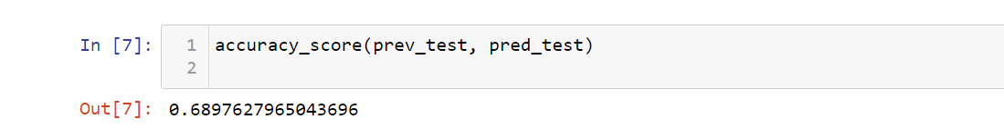

**Robust testing**

